# **BLOOD DONATION – 2023**

**TIME:** 1:00 PM onwards

**DATE:** 20 July 2022, Wednesday

**BJECTIVE:** Provide safe and quality blood and blood components collected from voluntary donors, round the clock, at affordable cost to the general public and free of cost to the poor

**NO OF STUDENTS PARTICIPATED:** All students (1st, 2nd, 3rd, 4th, 5th)

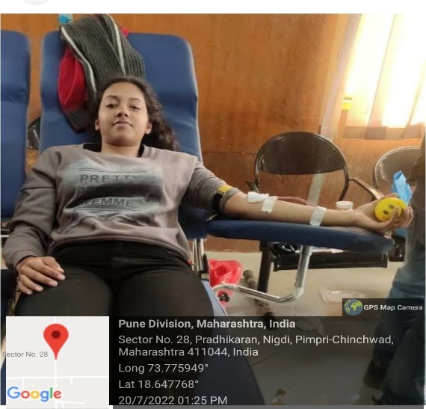Our College PDEACOA has been religiously organizing blood donation camps every year and students and the faculty members come forward voluntarily to donate blood. While addressing to people at the camp our NSS volunteers brought awareness in them about shortage of blood and why we must donate blood every year, to help the persons requiring blood. Blood donation can save lives of innumerable persons. Donation of blood is very critical and crucial for saving lives many patients and those who have met with accidents. It is as such a great service or contribution to the society and people living in it.

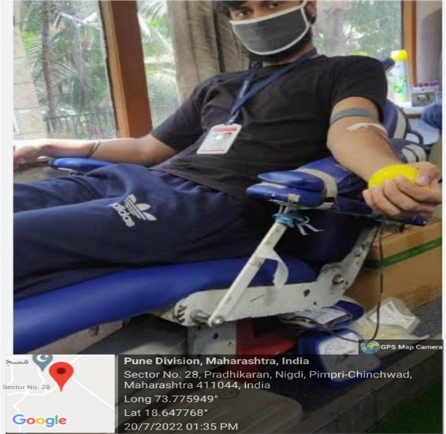

**Photos of BLOOD DONATION**

**Report by:**

**Er. Swati Bansode**

**Assistant Professor, PDEA College of Architecture**

**OUTCOME**

The annual blood donation camps organized by PDEACOA have become a commendable tradition, with both students and faculty members wholeheartedly participating in this noble cause. These camps serve as a platform for individuals to voluntarily donate blood, contributing to the lifesaving efforts of hospitals and healthcare facilities.

During the camps, our dedicated NSS volunteers play a crucial role in raising awareness about the importance of blood donation. They educate participants about the persistent shortage of blood supply and emphasize the critical role that regular blood donation plays in saving countless lives. By spreading awareness about the significance of blood donation, our volunteers aim to inspire more people to contribute to this humanitarian cause.

The impact of blood donation cannot be overstated, as it has the potential to make a profound difference in the lives of patients in need, including those battling illnesses and those who have suffered accidents or trauma. Through the selfless act of donating blood, individuals have the opportunity to directly impact and save the lives of others in their community.

Overall, the outcome of the blood donation camps organized by PDEACOA is truly commendable. Not only do these camps provide a platform for individuals to contribute to the betterment of society, but they also foster a sense of solidarity and compassion among students and faculty members. By actively participating in these camps, our college community exemplifies the values of altruism and service, making a meaningful and tangible impact on the lives of others.